**Problem Statement**

We are a wine producing company from Italy trying to capture the mid-range and expensive wine market in England. After analyzing the English market, we feel like we have the best quality wines in the world:

1. Merlot in Mid-Range and it is the cheapest around the world.
2. Prugnolo Gentile in the expensive range and we have the monopoly in the world.

Through this analysis report we would like to convey this huge business opportunity and try to convince the Director of the Board of Investors to give us a “Go-Ahead” to expand our business and enter the English Market.

**Our Dataset**

Our Wine Data Set has 15698 records. It has the following data points relevant to this study:

1. **Country** of Origin of the Wine: Australia, Chile, England, France, Germany, Italy, New Zealand, Spain and United States. (in the analysis when we say world, we mean these countries)
2. Quality **Points**: Depicts the quality of the wine on a scale of 0-100. We cleaned the data to consider only the wines in the Quality Points range 91-100.
3. **Price**: Price of the particular wine in each country mentioned above.
4. **Variety** of the wine: Bordeaux-style white blend, Prugnolo Gentile, Cabernet Blend, Muscat, Cabernet Sauvignon, Merlot, Pinot Noir, Red Blend, Chardonnay and Syrah.
5. Other than these data points the dataset also provides a description, designation, province of origin of each particular variety of wine.

**Analysis**

**Visualization 1:** Segmentation of variety of wines based on average price around the world.

We have identified three market segments based on the average price of wines. Affordable Wines, Mid-Range Wines and Expensive wines. Based on this segmentation we know which variety of wine falls under which segment as shown in the Visualization.

**Visualization 2:** Different varieties of wines produced around the world and the average Quality Points for each variety

Based on this visualization we analyzed that the English market has a very strong potential to grow when it comes to wine production and consumption. People only have 1 variety of local wine, Chardonnay, available to them to enjoy. Based on the average Quality Points, their local Chardonnay is best in the world. It falls under the affordable wine segment. Therefore, we decided only to try and capture the market for mid-range and expensive wines.

We also deduced that the Merlot we produce is the best quality and the cheapest wine in the world in the mid-range segment. Moreover, the price is very comparable to the Chardonnay. This gives us a distinct advantage of introducing a better quality wine at an affordable price to the English people.

In the expensive range, we would like to introduce our Prugnolo Gentile. We have the monopoly on the production of this variety of wine in the world. Therefore, it puts us in the best position to capture the English population that may have a finer taste for wines.

**Visualization 3:** Comparison of the average price and average quality points of the wines.

We present you with this comparison to convey the fact that higher price of wine does not convey a better quality wine. As you can see in the visualization, our Prugnolo Gentile is the best wine in terms of quality in the expensive range and is also, on average $9.5 cheaper than the Bordeaux-style white blend. Moreover, Merlot is the cheapest wine in its segment and still at par with the other wines in term of quality.

**Conclusion**

Based on our analysis, we conclude that we are in the best position, at present, to capture the English mid-range and expensive wine market with our Merlot and Prugnolo Gentile wines. We have the distinct advantage of cheaper price with the Merlot and the best quality of Prugnolo Gentile at our disposal. We urge the Board to give us the “Go-Ahead” to expand our business and enter the English Market.

Footnote: We would like the instructor to play the role of the Director of the Board of Investors of our company.

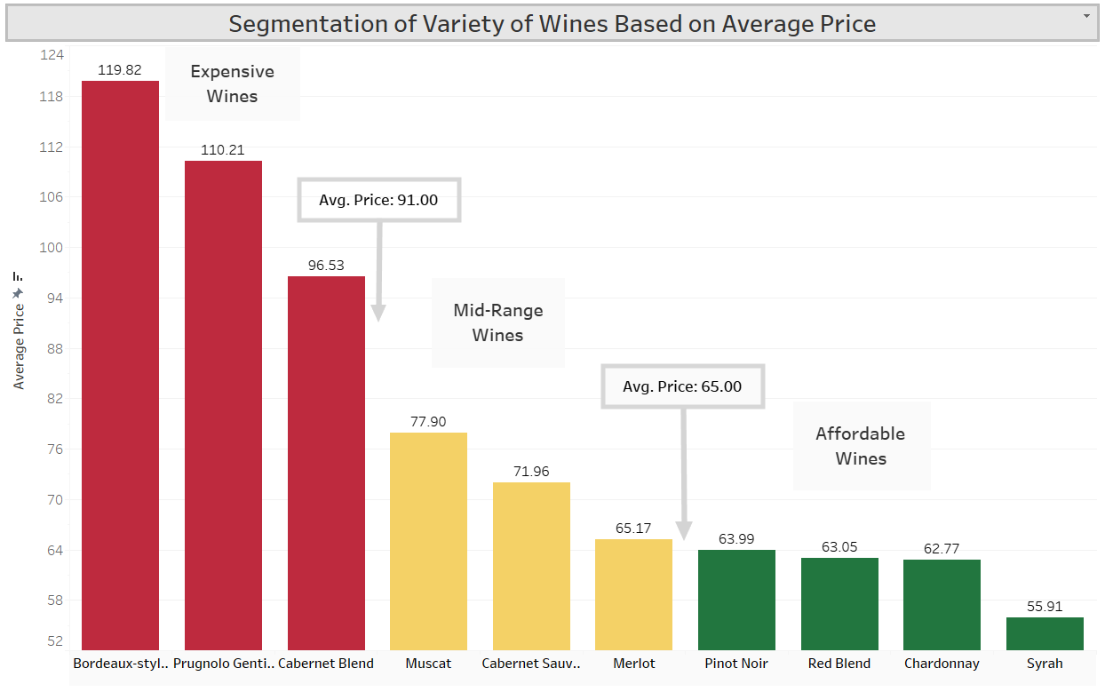

**Visualization 1:** Segmentation of variety of wines based on average price around the world.

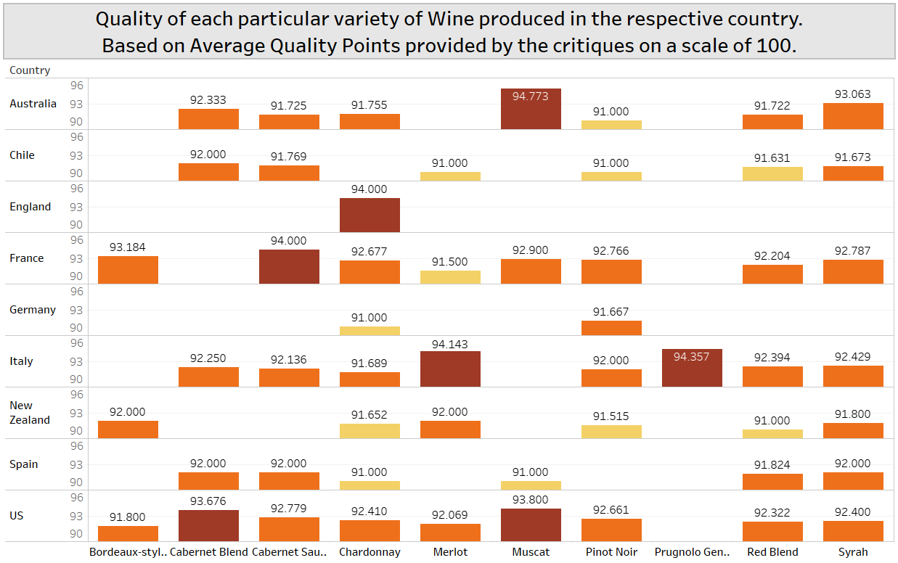

**Visualization 2:** Different varieties of wines produced around the world and the average Quality Points for each variety

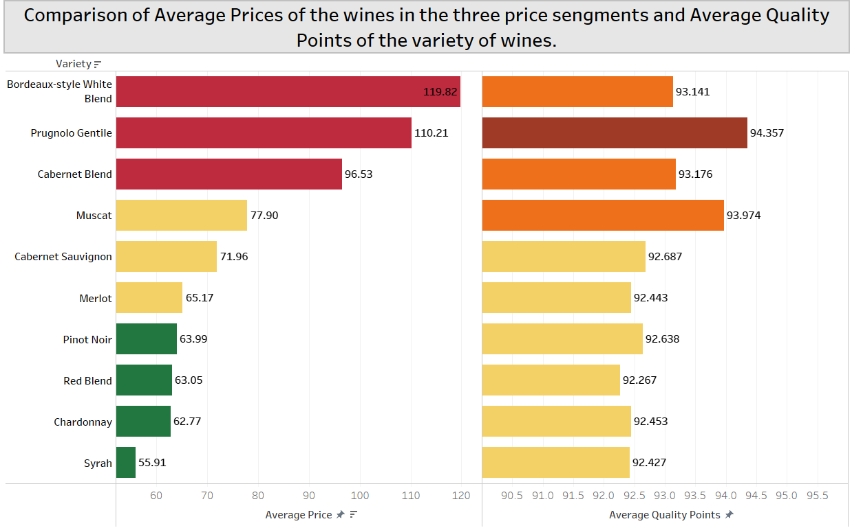

**Visualization 3:** Comparison of the average price and average quality points of the wines.